Main Classroom Activity
Name: Bibash Kumal
Subject: Fundamental of Software Engineeer
Section: C
Date: 24 september, 2026

Create Your Career Development plan.

Part 1: Target Career
One computing job role i select that is software Designing because in this field it helps user to serve blueprint for development, ensuring maintainability, scalability and useability.

Part 2: Career Requirements
Identify:
Five Required skill:
  - Programming Proficiency
  - Problem-solving
  - Algorithm Thinking
  - Web Development
  - Database management

Three area of Knowledge:
  - Interface Design
  - Architectural Design
  - Software Engineering Body of Knowledge

Two Competences:
  - Problem-Solving
  - Algorithm Thinking

Part 3: Personal Skill Audit
Identify:
Three current strengths:
  - Analysis
  - Planning
  - Design

Evidence for Each Strength:
A. Analysis:
Evidence:

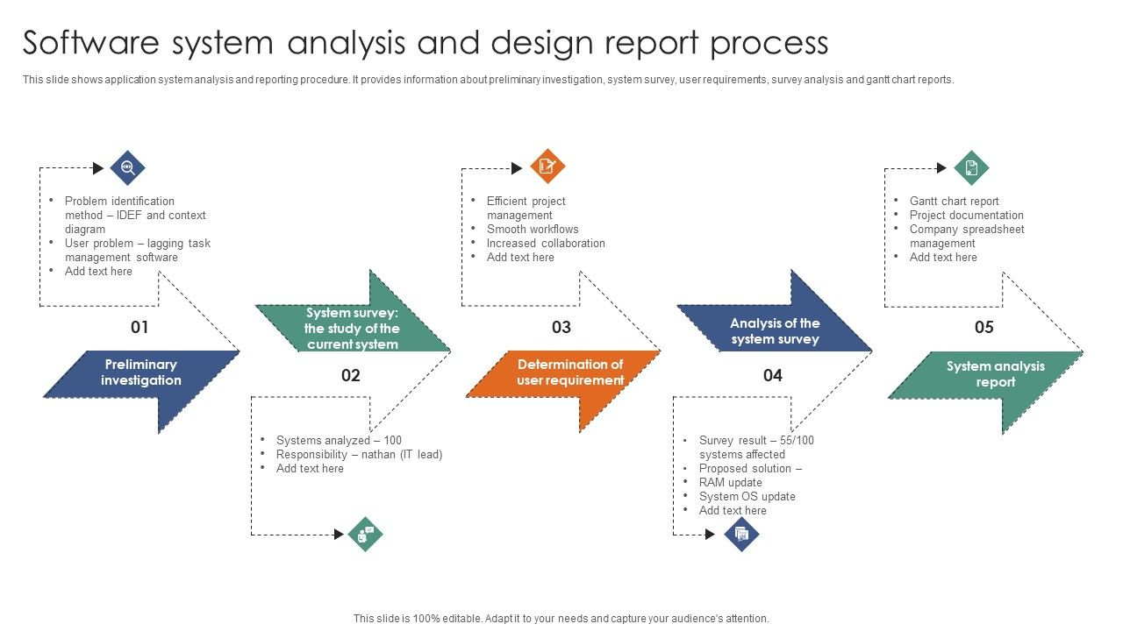
Link: https://www.slidegeeks.com/software-system-analysis-and-design-report-process-ppt-inspiration-background-designs-pdf
B. Planning
Evidence:
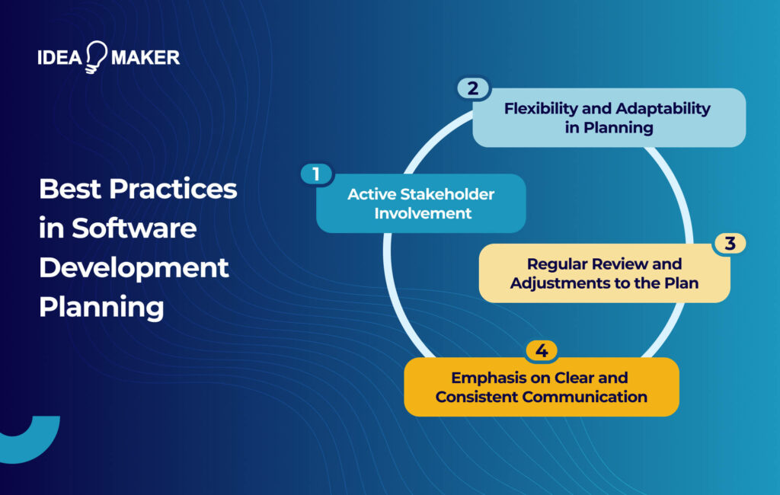
Source: https://ideamaker.agency/software-development-plan/
C. Design
Evidence:
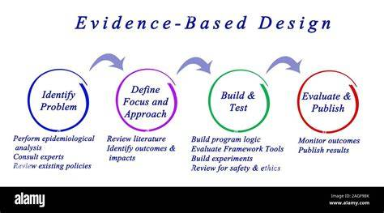
Source: https://cdaelementary.org/design-thinking-evidence-design-thinking-examples/
Two Important Development Area:
1. Defining Clear Interface
2. Consistent Architecture

Part 4: Career Goal
1. Self-Assessment
2. Define Your Career Goal
3. Structure Using A SMART Template

Part 5: Action Plan:
I am a beginner-level student working to improve my Python, web development, UML, database, and computational thinking skills. I will analyse my weaknesses, plan my study time, and use techniques such as Cornell Notes, mind mapping, regular revision, and practice exercises. I will also review my progress regularly and improve my study methods when needed.
Resources:
Class notes, textbooks, VLE materials, laptop/computer, Python, VS Code, internet, notebook, stationery, calendar, and teacher feedback.
Deadline:
I will follow this action plan for 4 weeks, with weekly progress reviews, and complete the final evaluation at the end of Week 4.

